**PROJECT REPORT ON**

“**Expense Tracker**”

# Submitted By:

Daksh Thakur, UID- 24MCA20014

# Under The Guidance of:

Mrs. Geetanjali Sharma



# CERTIFICATE

This is to certify that Daksh Thakur (UID- 24MCA20014) have successfully completed the project title “Expense Tracker” at University Institute of Computing under my supervision and guidance in the fulfilment of requirements of first semester, Master of Computer Application- Specialization in General. Of Chandigarh University, Mohali, Punjab.

Dr. Abdullah Mrs. Geetanjali Sharma

Head of the Department Project Guide Supervisor University Institute of Computing University Institute of Computing

# ACKNOWLEDGEMENT

We deem it a pleasure to acknowledge our sense of gratitude to our project guide Mrs. Geetanjali Sharma under whom we have carried out the project work. His incisive and objective guidance and timely advice encouraged us with constant flow of energy to continue the work.

We wish to reciprocate in full measure the kindness shown by Dr. Abdullah (H.O.D, University Institute of Computing) who inspired us with his valuable suggestions in successfully completing the project work.

We shall remain grateful to Dr. Manisha Malhotra, Additional Director, University Institute of Technology, for providing us a strong academic atmosphere by enforcing strict discipline to do the project work with utmost concentration and dedication.

Finally, we must say that no height is ever achieved without some sacrifices made at some end and it is here where we owe our special debt to our parents and our friends for showing their generous love and care throughout the entire period of time.

Date: 24.10.2024

Place: Chandigarh University, Mohali, Punjab

Daksh Thakur

UID- 24MCA20014

## ABSTRACT

The Expense Tracker project is a command-line tool designed to simplify personal finance management by enabling users to track their daily expenses in a lightweight, efficient manner. Built using shell scripting, this tool provides an accessible and minimalist approach to expense tracking that is compatible with Linux environments. Users can log expenditures with ease, view summaries of their spending habits, and track their financial activities over time directly from the terminal.

The primary goal of this project is to demonstrate the power and flexibility of shell scripting in solving practical, real-world problems. While the Expense Tracker focuses on core expense tracking functionality, it can be easily expanded with advanced features such as monthly summaries, category-based reports, and data export capabilities. This adaptability makes it an ideal solution for users seeking a simple, command-line-based financial tool that can grow with their needs.

This project also highlights the advantages of command-line tools, such as low resource consumption and enhanced user control, which make it particularly suitable for Linux users who prefer streamlined, script-based solutions. Overall, the Expense Tracker stands as a practical example of how Linux scripting can be leveraged for effective financial management, offering a blend of simplicity, functionality, and extendibility.

.

|  |  |
| --- | --- |
| 1. Introduction |  |
| 2. Project Objectives |  |
| 3.System Requirements |  |
| 4.Design and Features |  |
| 5. Challenges and Solutions |  |
| 6.Future Enhancements |  |
| 7. Conclusion |  |

# Introduction

* + The **Expense Tracker** is a command-line utility built to help users efficiently record and manage their daily expenses in a Linux environment. The project was conceived as a lightweight solution that allows users to interact directly through terminal commands.
  + **Purpose**: With a simple interface, this project demonstrates the potential of scripting to automate everyday tasks like expense management, eliminating the need for heavy, feature-rich applications for basic usage.

# Project Objectives

* + **Core Objectives**:
    - Create a minimalistic system for recording, listing, and deleting expenses.
    - Use simple shell scripting to implement core functionalities, ensuring the project runs on any Linux distribution with Bash support.
    - Store data persistently in a text file and allow easy access for modifications and audits.

# Additional Objectives:

* + - Implement basic validation to ensure correct input formats and valid data entry.
    - Create a summary feature that calculates the total expenses.
    - Explore the use of categories to differentiate types of expenses.

# System Requirements

* + **Operating System**: Tested on Ubuntu 20.04 LTS, but works across all major Linux distributions.
  + **Required Tools**: Bash, Text Editor, Linux Terminal.
  + **Target Audience**: Individuals who prefer a lightweight, command-line-based expense tracking solution without the need for GUI tools.

# Design and Features

* + **Data Storage**: Expenses are stored in a text file in a structured format. Each line contains:
    - **Date**: Automatically logged when the expense is added.
    - **Description**: The user's description of the expense.
    - **Amount**: The cost of the expense.
    - **Category**: Optional, used to classify the expense (e.g., Food, Travel, Entertainment).

# Steps

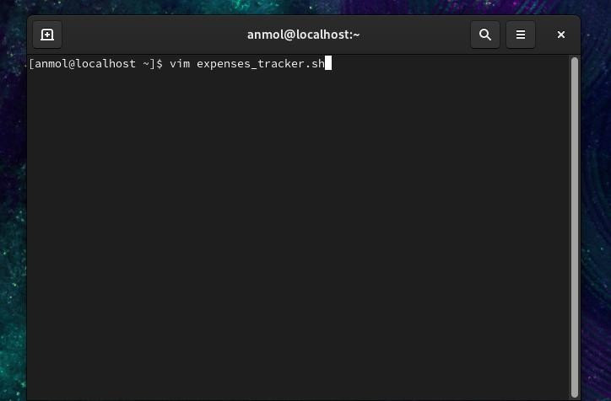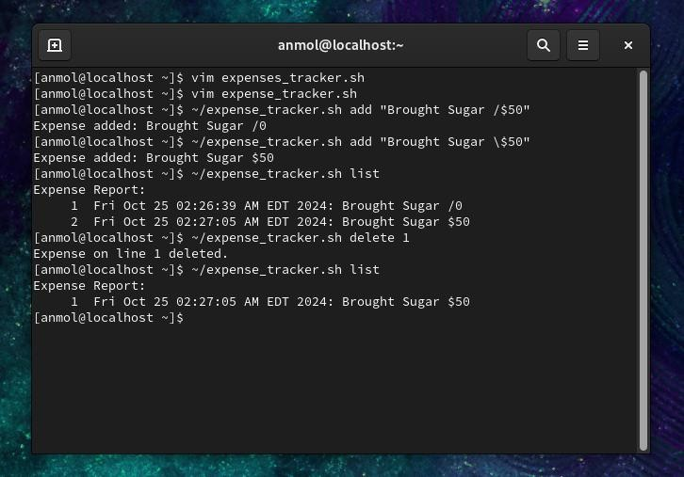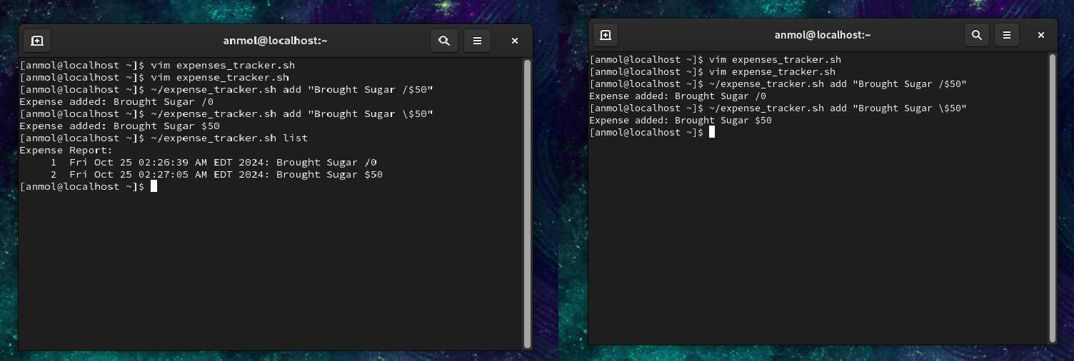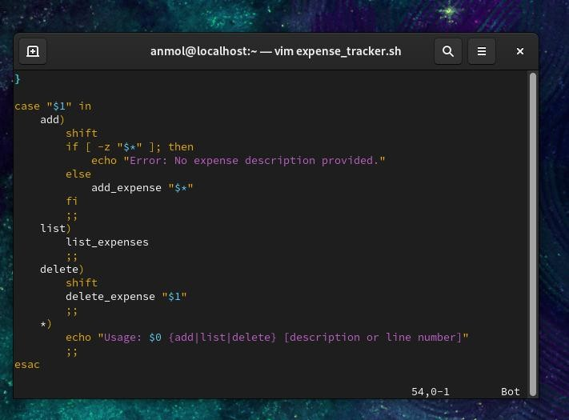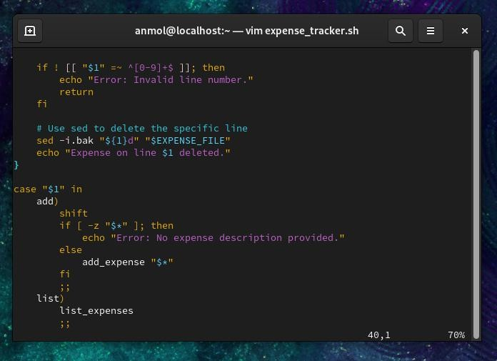

**\**

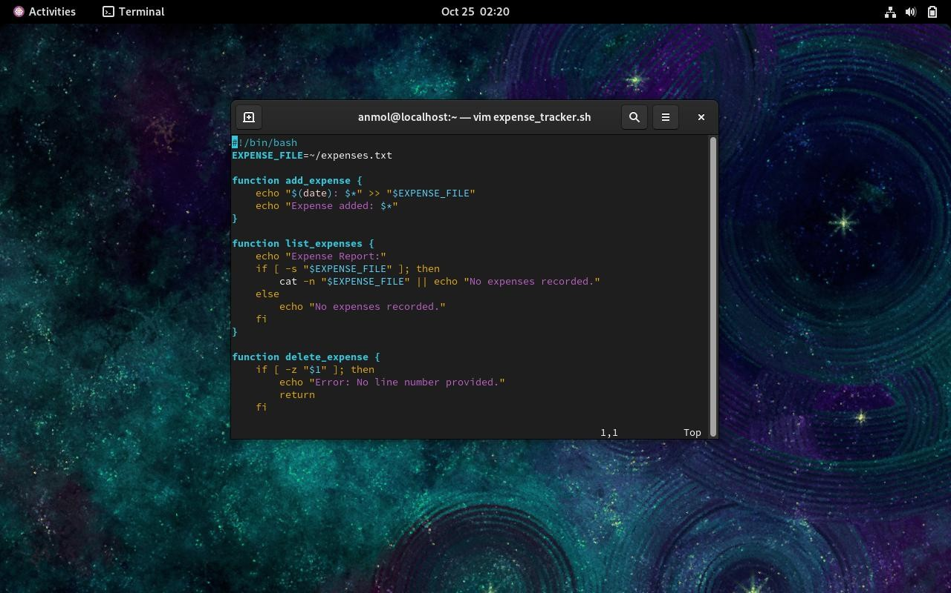

* + **Features**:
    - **Add Expense**: Adds a new expense entry, ensuring all necessary details are captured. The tool logs the current date and appends the expense data to a text file.
    - **List Expenses**: Lists all recorded expenses, displaying them in chronological order. Line numbers are shown to allow users to reference and manage specific entries.
    - **Delete Expense**: Removes a specified expense from the list, based on the line number.
    - **Expense Summary**: Provides a total of all recorded expenses, giving users a quick overview of their spending.
    - **Search and Filter** (Optional): Users can search for expenses by keywords or categories to track specific spending habits.

# Challenges and Solutions

* + **Data Integrity**:
    - One of the primary challenges in developing the expense tracker was ensuring the integrity of the data. The use of a simple text file for storage required meticulous formatting and validation to ensure no corrupted data was entered.
    - **Solution**: Implemented basic validation checks for input formats, ensuring only valid numerical values were accepted for amounts, and descriptions were not left empty.

# User Experience:

* + - Building a command-line tool that was intuitive yet powerful posed challenges in terms of making commands easily understandable.
    - **Solution**: Kept the commands short and descriptive. For example, add, list, and delete were chosen as the core functions. Help messages were also included to guide users when needed.

# Expense Categorization:

* + - While the core functionality involved adding and deleting expenses, introducing categories for better organization required additional thought on how to structure the input and output.
    - **Solution**: Categories were made optional but encouraged. The data format was adjusted to support categories without disrupting the ease of use.

# Future Enhancements

* + **Graphical Output**:
    - A potential enhancement would be the creation of graphical representations of the expense data. Pie charts or bar graphs could display spending by category or over time.
    - This could be done by integrating the tool with data visualization libraries or using command-line tools that create text-based graphs.

# User Authentication:

* + - The current tool is a single-user system, with all expenses stored in a single file. A future version could implement user authentication, allowing multiple users to track their expenses independently.
    - This could be achieved by storing each user's data in separate files and creating login credentials to secure access.

# Advanced Search and Filters:

* + - Expanding the search functionality to allow for more advanced queries, such as finding the highest or lowest expense or filtering by date range.
    - These features would add more flexibility to the tool, enabling users to dig deeper into their expense data.

# Expense Categories with Predefined Labels:

* + - While categories are optional in the current version, a future iteration could introduce predefined categories with specific labels (e.g., Food, Transportation, Entertainment). This would standardize the way expenses are recorded and allow for better data analysis.

# Exporting Data:

* + - Another potential enhancement is the ability to export expense data in various formats, such as CSV or JSON. This would make it easier for users to analyze their data in other programs like Excel or even upload it to cloud storage for safekeeping.

# Key Learning Outcomes

* + This project demonstrated the power of shell scripting in Linux to automate basic tasks and manage user input/output through the command line.
  + Key takeaways included:

Understanding file handling in Bash, particularly appending, reading, and deleting entries from a file.

* + - Implementing input validation to ensure that data entered into the system is accurate and in the correct format.
    - Designing a user-friendly interface within the constraints of the Linux command- line environment.
    - Exploring ways to make the tool more flexible for users by introducing optional features like categories and search.

1. **Conclusion**

The Expense Tracker project provides a practical, minimalist tool for tracking daily expenses directly from the command line. By offering simple, efficient commands, it allows users to easily record and monitor their spending without relying on complex software or interfaces. This tool fulfills its primary objective of expense tracking through straightforward functionality that is perfect for everyday use. Despite its basic design, it serves as a foundation that can be expanded with more advanced features like data visualization, category-based spending summaries, or export options, allowing for future growth in functionality.

In summary, the Expense Tracker is a powerful demonstration of how shell scripting in Linux can be applied to solve real-world challenges in a lightweight and accessible way. This project exemplifies the versatility and effectiveness of shell scripting by addressing a common need for expense tracking. Through its minimalistic approach, it showcases how even small scripts can have a meaningful impact, making it an ideal solution for users looking to manage their finances efficiently without additional software.